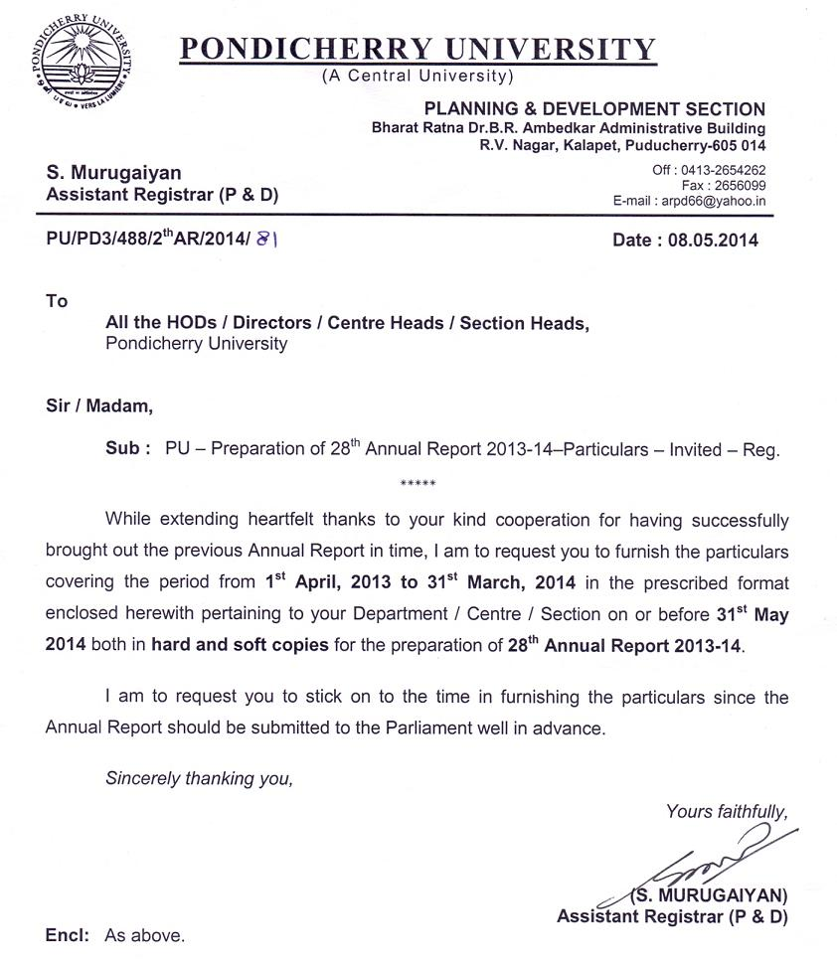
PORTION TO BE FILLED BY HEAD OF THE DEPARTMENTS / CENTRES
Name of the School : ……………………………………
Name of the Department / Centre : ……………………………………
Introduction (about Department in 100 words) :
Thrust Areas of Teaching and Research :

- Information on Faculty members
Sl.No. | Name of the faculty | Designation | Educational Qualification | Specialization | Date of Joining | Date of appointment in present position

- Students strength during the year 2013-14
Courses Offered | No. of Students
 | Male | Female | Total

- Details of Conference / Workshops / National / International Seminar / Training Courses organized by the department during 2013-14.
- Special lecture series, if any
Sl.No. | Name & Institution of the guest faculty | Date | Topic

- Scholarship / Fellowship and any other financial assistance received by the students / Scholars.
Course | Name of the scholarship | No. of students
P.G.
M.Phil.
Ph.D., | UGC
Ph.D., | CSIR
Ph.D., | Rajiv Gandhi
Ph.D., | Pondicherry University
Ph.D., | Any other

- Details of SAP / FIST / Innovative Programme etc. sanctioned
- No. of PG students qualified in UGC / CSIR / NET / GATE / SLET / Any other National Level Test (2013-14)
National Level Test | Appeared | Qualified
UGC
CSIR/NET
GATE
SLET

- Distinguished visitors for the year 2013-14
- Development of Infrastructure
- Co-curricular and Extra curricular activities during the year 2013-14
- Sports activities and achievements during the year 2013-14
- Attach Good Photos (3 Nos.) of events conducted by the department during the year
2013-14 (please send prints as well as soft copy on CD).
Signature of Head of the Department
PORTION TO BE FILLED BY THE INDIVIDUAL FACULTY
(Any column with insufficient data / information will be rejected)

Name :
Designation :
Department :
Date of appointment in present position :

Academic Distinctions
- Awards / Prizes / Honours received during the year 2013-14

Academic Outreach
- Details of Lecturers delivered in India / Abroad during the year 2013-14

Conference papers
- Paper presented National and International Conferences / Workshops
Sl.No. | Title of the paper presented | Name of the Conference/Seminar | Place | Date

Research Publications from 1st April, 2013 to 31st March, 2014
(do not repeat the published papers in conference volumes)
- List of published research papers in National / International journal (Please mention the Name(s) of authors, year, title of the article, name of the journal, name of the publication, volume, page number).
- Details of Books published / edited if any during the year 2013-14 with title, publisher, year.

Signature of the faculty
Signature of Head of the Department

PORTION TO BE FILLED BY ACADEMIC SECTION

Courses Offered
- On Campus :
- Affiliated Colleges / Institutions
- No. of Colleges in Puducherry :
- No. of Colleges in Karaikal :
- No. of Colleges in Mahe :
- No. of Colleges in Yanam :
- No. of Colleges in Andaman & Nicobar Islands :
- No. of Colleges in Tamil Nadu :
- Any Other (specify name) :
Admission
- Students admitted during 2013-14 at a glance
Course | Application Received |  |  |  |  |  |  |  | Candidates Admitted
 | Gen | OBC | Min. | SC | ST | PH | FS | Tot | Gen | OBC | Min. | SC | ST | PH | FS | Tot
Ph.D.
M.Phil.
M.Tech.
M.A.
M.Sc.
M.Sc.(Int)
M.B.A.
M.C.A.
Cert. & Diploma
Others
Total
[FS – Foreign Students]

- Students details of Affiliated Colleges during the year 2013-14
Sl. No. | Name of the College | Admission |  |  | Male |  |  |  |  |  |  | Female
Sl. No. | Name of the College | Total | M | F | GEN | OBC | Min | SC | ST | PH | FS | GEN | OBC | Min | SC | ST | PH | FS
[FS – Foreign Students]

- Sanctioned and admitted strength of students in Dept./Course-wise during 2013-14
Sl.No. | Name of the Course/Dept. | Ph.D. |  | M.Phil. |  | MA,M.Sc.,  M.Sc. Integ. |  | MBA/ MCA/  M.Tech |  | Dip./Cert. |  | Others |  | Total
1 |  | S | A | S | A | S | A | S | A | S | A | S | A | S | A
 | Total
(S – Sanctioned; A – Admitted)

- Students On Roll in P.G./M.Phil./Ph.D. during 2013-14
Sl. No. | Name of the Course/ Dept. | Year | M.Sc Integ., |  |  | P.G. |  |  | M.Phil. |  |  | Ph.D.
Sl. No. | Name of the Course/ Dept. | Year | M | F | T | M | F | T | M | F | T | M | F | T
1 |  | I Year
 |  | II Year
 |  | III Year
 |  | IV Year
 |  | V Year
 | Total
- Students On Roll in P.G./M.Phil./Ph.D. in Category-wise during 2013-14
Course | No. of Students On Roll
 | Gen | OBC | Min. | SC | ST | PH | FS | Total
Ph.D.
M.Phil.
M.Tech.
M.A.
M.Sc.
M.Sc.(Int)
M.B.A.
M.C.A.
Cert. & Diploma
Others
Total
- No. of students in Postgraduate degree awarded in Course-wise during 2013-14
Course | No. of students appeared |  | No. of students passed
 | Male | Female | Male | Female
Total
- Institutions recognized for Research.
- MOU / Collaborations with other universities / institutions.
- New Programmes developed during 2013-14.
Name of the programme | Department | School

- Meetings of the University Authorities conducted during 2013-14.
1) Executive Council :
2) Academic Council :
- List of Members of the University Authorities during 2013-14.
1) Executive Council :
2) Academic Council :

Signature of the Head
PORTION TO BE FILLED BY ACADEMIC STAFF COLLEGE

- Name of the Director
- Introduction (in 200 words)
- Information on Faculty members
Sl.No. | Name of the faculty | Designation | Educational Qualification | Specialization | Date of Joining | Date of appointment in present position

- Programmes organized during 2013-14
- List of Publications
- Plan for 2014-15, if any

Signature of the Head

PORTION TO BE FILLED BY COLLEGE DEVELOPMENT COUNCIL

- Name of the Dean
- Introduction (in 100 words)
- Details of Affiliated colleges / institutions as on 31.03.2014
Sl.No. | Colleges / Institutions | Principal / Dean / Director | Year of Estt. | Courses offered

- Number of inspections carried during 2013-14
- Colleges with Autonomous Status
- Colleges with permanent affiliation
- Colleges under 2f – 12b
- Any other information

Signature of the Dean

PORTION TO BE FILLED BY CENTRAL LIBRARY

- Name of the Librarian
- Introduction
- No. of total collections
Collection | As on 01.04.2013 | In 2013-14 Purchased / Subscribed | Total as on 31.03.2014
Books
Theses
UN Documents
Total
Journals back volumes
Electronic journals back files
Print journals
e-journals
Any others
Total

- Expenditure for collections
- Usage of e-resources
Usage of e-resources | 2013-14
University Subscription
UGC-Infonet Subscription
Any others
Total

- Programmes organized
- Development of Infrastructure

Signature of the Head

PORTION TO BE FILLED BY CENTRAL INSTRUMENTATION FACILITY

- Name of the Officer & Designation
- Introduction (in 200 words)
- Programmes organized during 2013-14
- List of Instruments and procurement during 2013-14 with cost.

Signature of the Head

PORTION TO BE FILLED BY PONDICHERRY UNIVERSITY COMMUNITY COLLEGE

- Name of the Principal
- Introduction (in 200 words)
- Courses offered
- Admissions for the year 2013-14
Course | Male |  |  |  |  |  |  |  | Female
 | Gen | OBC | Min. | SC | ST | PH | FS | Tot | Gen | OBC | Min. | SC | ST | PH | FS | Tot
(FS – Foreign Students)

- Degree / Diplomas Awarded for the year 2013-14 (Subject-wise)
Sl.No. | Course Name | Appeared |  | Passed |  | Awarded
Sl.No. | Course Name | Male | Female | Male | Female | Male | Female

- Students Strength during 2013-14
Sl.No. | Composition | Degree | PG Diploma | Diploma | Certificate | Total
1 | Boys
 | General
 | OBC
 | Minorities
 | SC
 | ST
 | PH
 | FS
 | Total (1)
2 | Girls
 | General
 | OBC
 | Minorities
 | SC
 | ST
 | PH
 | FS
 | Total (2)
 | Total (1+2)
(FS – Foreign Students)

- Details of Seminars / Conferences / Trainings organized
- Details of Visits / Distinguished visitors
- Development of Infrastructure
- Co-curricular and Extra curricular activities during the year 2013-14
- Sports activities and achievements during the year 2013-14
- Plan for 2013-14, if any

Signature of the Head
PORTION TO BE FILLED BY COMPUTER CENTRE
- Name of the Officer with Designation
- Introduction (in 200 words)
- Programmes organized during 2013-14
- Any other information
Signature of the Head

PORTION TO BE FILLED BY DAY CARE CENTRE

- Name of the Officer & Designation
- Introduction (in 200 words)
- Programmes organized

Signature of the Head

PORTION TO BE FILLED BY DIRECTORATE OF DISTANCE EDUCATION

- Name of the Director
- Introduction (in 200 words)
- Courses offered
- Admissions for the year 2013-14
Course | Male |  |  |  |  |  |  |  | Female
 | Gen | OBC | Min. | SC | ST | PH | FS | Tot | Gen | OBC | Min. | SC | ST | PH | FS | Tot
(FS – Foreign Students)

- Degree / Diplomas Awarded for the year 2013-14 (Subject-wise)
Sl.No. | Course Name | Appeared |  | Passed |  | Awarded
Sl.No. | Course Name | Male | Female | Male | Female | Male | Female

- Future Vision in 4 to 5 sentences)

Signature of the Head

PORTION TO BE FILLED BY ESTABLISHMENT SECTION

- No. of Teaching positions filled during 2013-14
Professors |  | Reader /  Assoc. Professor |  | Assistant Professor |  | Total
Male | Female | Male | Female | Male | Female | Male | Female

- Current Strength of faculty
Professors |  | Reader /  Assoc. Professor |  | Assistant Professor |  | Total
Male | Female | Male | Female | Male | Female | Male | Female

- Faculty Profile
 | Ph.D.  in % | SC |  | ST |  | PH |  | Women |  | Minorities
 | Ph.D.  in % | No. | % | No. | % | No. | % | No. | % | No. | %
Professors | 100%
Reader / Assoc. Professor | 100%
Assistant Professor

- School wise faculty strength as on 31st March, 2014
Sl.No. | Name of the Dept./School | No. of Post
Sl.No. | Name of the Dept./School | Professor |  |  | Reader / Assoc. Prof. |  |  | Asst. Professor |  |  | G. Tot
Sl.No. | Name of the Dept./School | Direct | CAS | Tot | Direct | CAS | Tot | Direct | CAS | Tot | G. Tot
 | Total

- Appointment of New Faculty under Direct Recruitment during the year 2013-14
Sl.No. | Name | Designation | Department | Date of Appointment

- Promotion of Faculty under Career Advancement Scheme During 2013-14 Reader to Professor
Sl.No. | Name | Dept. | w.e.f

Lecturer (SS / SG) to Reader
Sl.No. | Name | Dept. | w.e.f

Lecturer (SS) to Lecturer (SG)
Sl.No. | Name | Dept. | w.e.f

Lecturer to Lecturer (SS)
Sl.No. | Name | Dept. | w.e.f

- Faculty on leave
Sl.No. | Name & Dept. | Nature of Leave | Period

- Faculty Resignation
Sl.No. | Name & Desgn. | Department | Date

- Details of Visit of Faculty to Foreign Countries
Sl.No. | Name & Desgn. | Place & Purpose of Visit

- New appointments (Administration)
Sl.No. | Name & Designation | Date of Joining

- Administrative Retirement / Resignation
Sl.No. | Name & Designation | Date of Retirement / Resignation

- Total Non-Teaching Staff Strength as on 31.03.2014
Category | Gen | OBC | Min. | SC | ST | PH | Total
Statutory Officers
Group ‘A’ Officers
Group ‘B’ Officers
Group ‘C’ Staff
Group ‘D’ Staff
Total - A
Consolidated/Contract/Daily Wages
Others
Total - B
Grand Total (A+B)

Signature of the Head

PORTION TO BE FILLED BY EXAMINATIONS WING

- No. of students in Postgraduate degree awarded in Course-wise during 2013-14
Course | No. of students appeared |  | No. of students passed
 | Male | Female | Male | Female
Total

- No. of students in M.Phil. & Ph.D. degrees awarded during 2013-14
Department / Subject | M.Phil. |  | Ph.D.
 | Dissertation Submitted | Awarded | Dissertation Submitted | Awarded
Total

- Details of Dissertations submitted by M.Phil. candidates in University during 2013-14
Sl. No. | Name of the Scholar  (Dept. wise) | Name of the supervisor | Title of the Dissertation

- Details of Thesis submitted by Ph.D. candidates in University during 2013-14
Sl. No. | Name of the Scholar  (Dept. wise) | Name of the supervisor | Subject | Title of the thesis

- Details of Dissertation submitted by M.Phil. candidates in Affiliated Colleges (Subject-wise).
Sl. No. | Name of the Scholar  (Dept. wise) | Name of the Supervisor | Subject | Title of the thesis

- Details of Thesis submitted by Ph.D., candidates in Affiliated Colleges (Subject-wise)
Sl. No. | Name of the Scholar  (Dept. wise) | Name of the Supervisor | Subject | Title of the thesis

- No. of various Degrees / Diplomas Awarded during 2013-14 (University Depts., Affiliated Colleges, DDE and Community College)
S.No. | Degree | University | Affiliated | DDE | Community College | Total
1 | Ph.D
2 | M.Phil
4 | PG
5 | UG
6 | Others
 | Total

- Details of Examination Results of Affiliated Institutions for the Academic Year 2013-14

Sl. N. | Course Name | Subject  [(e.g.)B.A. Tamil] | Undergraduate |  |  |  |  |  | Postgraduate
Sl. N. | Course Name | Subject  [(e.g.)B.A. Tamil] | Appeared |  | Tot | Passed |  | Tot | Appeared |  | Tot | Passed |  | Tot
Sl. N. | Course Name | Subject  [(e.g.)B.A. Tamil] | M | F |  | M | F |  | M | F |  | M | F
I | Arts
II | Science
III | Comp Science / Application
IV | Commerce
V | Management
VI | Education
VII | Engineering/  Technology
VIII | Medicine
IX | Agriculture
X | Veterinary  science
XI | law
XII | Others
 | Grand Total

Signature of the Head
PORTION TO BE FILLED BY FINANCE & ACCOUNTS

- Expenditure on Developmental activities 2013-14

 | Under Plan | Under OBC
Construction of Building
Building Maintenance
Library maintenance
Books
Journals
Equipment
Laboratory
Furniture Acquisition and Maintenance
Computer Laboratory
Campus Networking
Computer Maintenance & Upgradation
Campus Development - Landscapes & other Development
Sports amenities
Support system (Electrical / Maintenance, ect.,)
Transport
Outsourcing services
Any others

- Details of Receipts and Payments

 | Receipts | Payment
Opening Balance as on 01.04.2013
Non-Plan
Plan
Earmarked Special Fund
Debt. And Deposit, CPF, GPF and University Funds
Closing Balance as on 31.03.2014

- Details of item wise expenditure on
  - Maintenance Grant (Non-Plan)
  - General Development Schemes (Plan)
  - Earmarked Special Fund (EMSF)
  - Debt. And Deposit, GPF, CPF and University Funds
- Meetings of the University Authorities conducted during 2013-14.
1) Finance Committee :
- List of Members of the University Authorities during 2013-14.
1) Finance Committee :

Signature of the Head
PORTION TO BE FILLED BY HEALTH CARE CENTRE
- Name of the Physician
- Introduction (in 200 words)
- List of Medical facility provided
- Details of patients seen in 2013-14
- Details of treatment provided
- Programmes organized during 2013-14

Signature of the Head

PORTION TO BE FILLED BY CHIEF WARDEN, HOSTEL

- Name of the Chief Warden
- List of Hostels with names of wardens & student capacity.
- Details of Accommodation
Sl.  No. | Name of the Hostel | Year of  Estt. | Type of  Accommodation | No. of  Rooms | Total no.  of inmates  during the  year | Admissions
 |  |  |  |  |  | SC | ST

- Hostel Mess
- Fees
- Fee concessions
- General Facilities

Signature of the Head

PORTION TO BE FILLED BY PLACEMENT CELL

- Name of the Officer & Designation
- Introduction (in 200 words)
- Details of placement of students of the University departments during 2013-14
Period | Name of the Department / Course | No. of Placement
2013-14

- Details of placements of students of the affiliated colleges during 2013-14
Period | Name of the Department / Course | No. of Placement
2013-14

- Plan for 2014-15, if any.

Signature of the Head

PORTION TO BE FILLED BY PLANNING AND DEVELOPMENT AND HORTICULTURE

- Buildings Completed during 2013-14
  - On Campus
  - Port Blair Campus
  - Karaikal Campus
- Work in Progress
  - On Campus
  - Port Blair Campus
  - Karaikal Campus
- Resource Mobilization under various heads
- Any other developmental activities
- Horticulture activities

- Meetings of the University Authorities conducted during 2013-14.
1) Court :
2) Planning Board :

- List of Members of the University Authorities during 2013-14.
1) Court :
2) Planning Board :

Signature of the Head

PORTION TO BE FILLED BY PROJECT CELL

- Total projects as on date :
- Total cost from projects :
- Details of research projects sanctioned during 2013-14
Sl.No. | Title of the Project and Name of the Investigator | Sponsoring Authority and Sanction Lr.No. with date | Total funds provided (Rs.in lakhs) | No. of JRF / SRF / RA | Others

- Award of Research Associateships, Fellowships & Scholarships during 2013-14
Sl. No. | Name of the award | Total Number of Awardees

Signature of the Head

PORTION TO BE FILLED BY PUDUVAI VANI 107.8 MHZ-COMMUNITY RADIO STATION

- Name of the Officer & Designation
- Introduction (in 200 words)
- Special Programmes organized
- Plan for 2014-15, if any

Signature of the Head

PORTION TO BE FILLED BY SC/ST CELL

- Introduction in 100 words
- Details of SC/ST and Women candidates admitted during the year 2013-14
- Details of reservation, scholarship etc. to various courses during 2013-14
- Any other information

Signature of the Head

PORTION TO BE FILLED BY TRAINING CELL

- Name of the Officer & Designation
- Introduction (in 200 words)
- List of training programmes conducted during the year 2013-14 (1st April, 2013 to 31st March, 2014)
- Plan for 2014-15, if any

Signature of the Head

PORTION TO BE FILLED BY MULTIMEDIA PRODUCTION CENTRE

- Name of the Officer & Designation
- Introduction (in 200 words)
- Special Programmes organized
- Plan for 2014-15, if any

Signature of the Head
PONDICHERRY UNIVERSITY
28th ANNUAL REPORT 2013-14
(1st April 2013 to 31st March 2014)
(Must reach by 31st May, 2014)
(Any column with insufficient data / information will summarily be rejected)
FORMAT – II for Affiliated Institutions
- Name of the College / Institution :
- Year of establishment :
- Name of the Principal / Dean / Director :
- No. of Students admitted during 2013-14
Sl. No. | Name of the Course  [(e.g.)B.A. Tamil] | Admission |  |  | Male |  |  |  |  |  |  | Female
Sl. No. | Name of the Course  [(e.g.)B.A. Tamil] | Total | M | F | GEN | OBC | Min | SC | ST | PH | FS | GEN | OBC | Min | SC | ST | PH | FS

- No. of Students on Roll during 2013-14
Sl. No. | Name of the Course  [(e.g.)B.A. Tamil] | On Roll |  |  | Male |  |  |  |  |  |  | Female
Sl. No. | Name of the Course  [(e.g.)B.A. Tamil] | Total | M | F | GEN | OBC | Min | SC | ST | PH | FS | GEN | OBC | Min | SC | ST | PH | FS
[FS – Foreign Students]

- Distinctions / Awards / Prizes / Honours received by the faculty.
Sl.No. | Name of the faculty | Name of the award | Given by | Date of the awarded

- No. of Students enrolled in NSS / NCC during 2013-14 :
- Achievements of the students at National / International level.
- Conference / Seminars / Workshops organized by the college and sponsored by UGC, AICTE, CSIR, DBT etc.
Sl.No. | Title of the conference | Period | Sponsoring Agency

- Details of projects sanctioned and being implemented during 2013-14.
Sl.No. | Title of the Project and Name of the Investigator | Sponsoring Authority and Sanction Lr.No. with date | Total funds provided (Rs.in lakhs) | No. of JRF / SRF / RA | Others

- Research publications by the faculty in National / International journals (Please mention the Name(s) of authors, title of the article, name of the journal, volume, page number, year).

- Any other matter of importance which, deserves to be included in the Annual Report.

Signature of the Head of the Institution with the Seal

