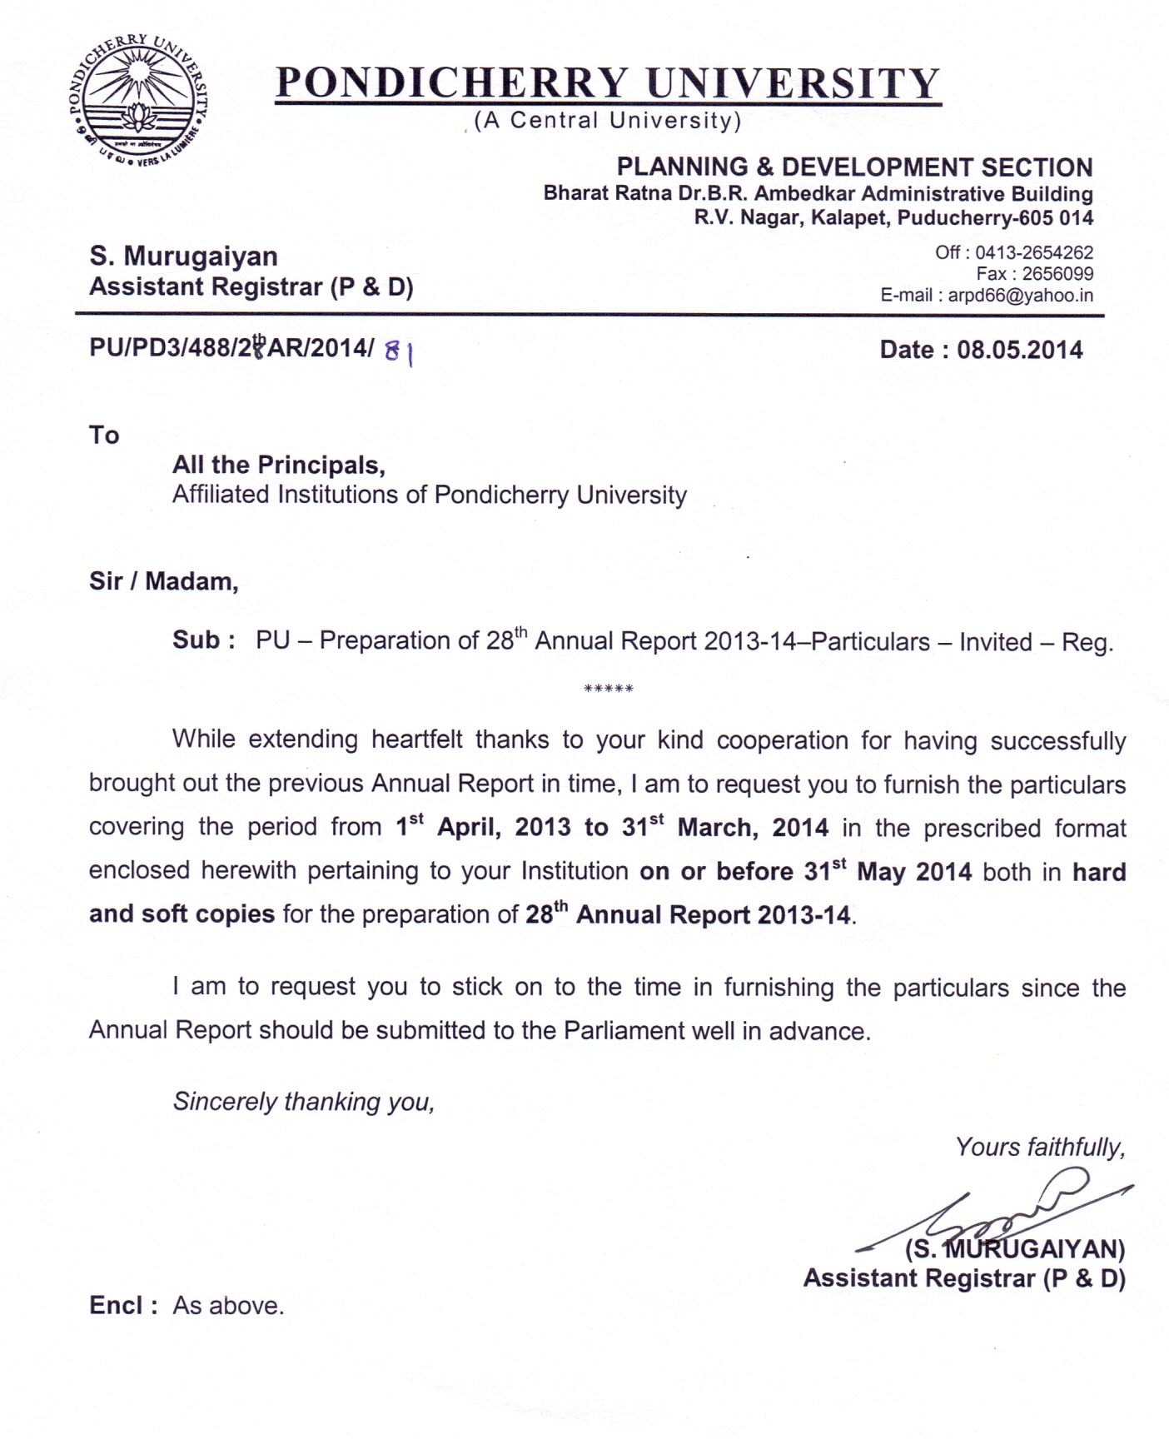
PONDICHERRY UNIVERSITY
28th ANNUAL REPORT 2013-14
(1st April 2013 to 31st March 2014)
(Must reach by 31st May, 2014)
(Any column with insufficient data / information will summarily be rejected)
FORMAT – II for Affiliated Institutions
- Name of the College / Institution :
- Year of establishment :
- Name of the Principal / Dean / Director :
- No. of Students admitted during 2013-14
Sl. No. | Name of the Course  [(e.g.)B.A. Tamil] | Admission |  |  | Male |  |  |  |  |  |  | Female
Sl. No. | Name of the Course  [(e.g.)B.A. Tamil] | Total | M | F | GEN | OBC | Min | SC | ST | PH | FS | GEN | OBC | Min | SC | ST | PH | FS

- No. of Students on Roll during 2013-14
Sl. No. | Name of the Course  [(e.g.)B.A. Tamil] | On Roll |  |  | Male |  |  |  |  |  |  | Female
Sl. No. | Name of the Course  [(e.g.)B.A. Tamil] | Total | M | F | GEN | OBC | Min | SC | ST | PH | FS | GEN | OBC | Min | SC | ST | PH | FS
[FS – Foreign Students]

- Distinctions / Awards / Prizes / Honours received by the faculty.
Sl.No. | Name of the faculty | Name of the award | Given by | Date of the awarded

- No. of Students enrolled in NSS / NCC during 2013-14 :
- Achievements of the students at National / International level.
- Conference / Seminars / Workshops organized by the college and sponsored by UGC, AICTE, CSIR, DBT etc.
Sl.No. | Title of the conference | Period | Sponsoring Agency

- Details of projects sanctioned and being implemented during 2013-14.
Sl.No. | Title of the Project and Name of the Investigator | Sponsoring Authority and Sanction Lr.No. with date | Total funds provided (Rs.in lakhs) | No. of JRF / SRF / RA | Others

- Research publications by the faculty in National / International journals (Please mention the Name(s) of authors, title of the article, name of the journal, volume, page number, year).

- Any other matter of importance which, deserves to be included in the Annual Report.

Signature of the Head of the Institution with the Seal

